Group 2

- Complete the sentences with the phrase segments given below

WWI was a long and static war: the trench war lead to the development of new war techniques, as machine guns, tanks and aviation. __; a decade later first planes were used during WWI to avoid trenches and fly over them.
__, by the end of the war fielded about 4,500 aircrafts. Seems a little amount, but 77% of the planes produced by France during WWI were lost in battle.
__: observation and reconnaissance, tactical and strategic bombing, ground attack, naval warfare and aerial fight.
__, often refusing the boring static trench war and trying to fly in the skies with rudimentary airplanes with a steel body and wooden parts and a limited maneuverability. __was Manfred von Richthofen, also known as the Red baron, with 80 air battles won. The most famous Italian ace was Francesco Baracca; when he was killed in June 1918 his mother gifted Enzo Ferrari with the symbol of their family, a prancing horse.

a. Some soldiers choose to enjoy aviation
b. In 1903 Wright Brothers invented the first airplane
c. The greatest ace of the war
d. During this period, tasks that aircraft could carry out were experimented and refined
e. France in 1914 had a 140 aircrafts fleet

Solution: b – e – d – a – c

- During WWI a new type of weapon was developed: chemical weapon.

During WWI a wide range of chemical weapons was used, despite being banned with a treaty in 1899 and in a second treaty signed by all future belligerent nations of WWI, except Italy, US and Ottoman Empire.
Chemical weapons were firstly used by France in 1914, but seriously developed by Germans.
Often a side effect of these gases, temporary or permanent, was blindness and respiratory illness. 3% of people who suffered an attack by chemical weapons died, and another 2% was permanently incapacitated, but nearly ¾ were fit for active duty again within 6 months.

Gas type Effects Other information
Tear gas | Some symptoms of exposure took about 24 hrs to manifest. Difficult to detect, killed 85% of 100,000 deaths caused by chemical weapons in WWI. | Unleashed by Germany in 1917.
Chlorine gas | Not a particular killer, but incapacitated people just touching their skin. Gas masks didn’t work against it. It was yellow and heavy and resisted for months. | Produced by the French.
Phosgene gas | Irritant and not deadly. | Produced by Germany in 1914.
Mustard gas | Like a greenish-gray cloud of smoke. Was a powerful irritant for eyes, nose, throat and lungs. | Firstly introduced by French in 1914. No one considered the use of it as a violation of the 1899 treaty.

Solution:

Tear gas | Irritant and not deadly. | Firstly introduced by French in 1914. No one considered the use of it as a violation of the 1899 treaty.
Chlorine gas | Like a greenish-gray cloud of smoke. Was a powerful irritant for eyes, nose, throat and lungs. | Produced by Germany in 1914.
Phosgene gas | Some symptoms of exposure took about 24 hrs to manifest. Difficult to detect, killed 85% of 100,000 deaths caused by chemical weapons in WWI. | Produced by the French.
Mustard gas | Not a particular killer, but incapacitated people just touching their skin. Gas masks didn’t work against it. It was yellow and heavy and resisted for months. | Unleashed by Germany in 1917.

3. Match the correct picture with the correct description.
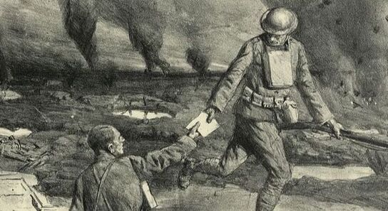
1

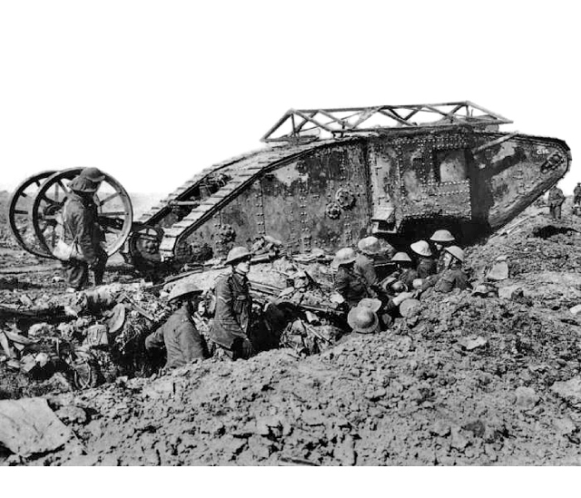
a)Telephone lines were used in all the conflict, but cables had to be dug in. Tanks were used to place telephone lines.
3
2
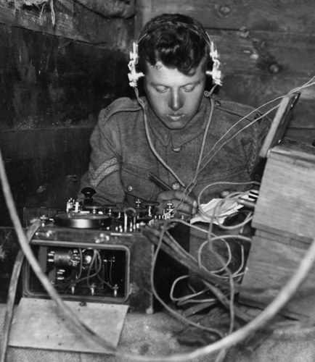
Solution: 1 c 2 a 3 b
c)The runners were really useful to sneak between trenches and bring messages from head quarters.

b) In 1917 only there was a widespread use of wireless radio. Before, all methods of communication used were useful only to connect trenches and head quarters but useless when soldiers left trenches.

